Creating a Facebook Account

Open your internet browser (Internet Explorer, Chrome, Firefox etc.) and type www.facebook.com in the search bar, which shows at the top of your screen.

You will then see this screen:
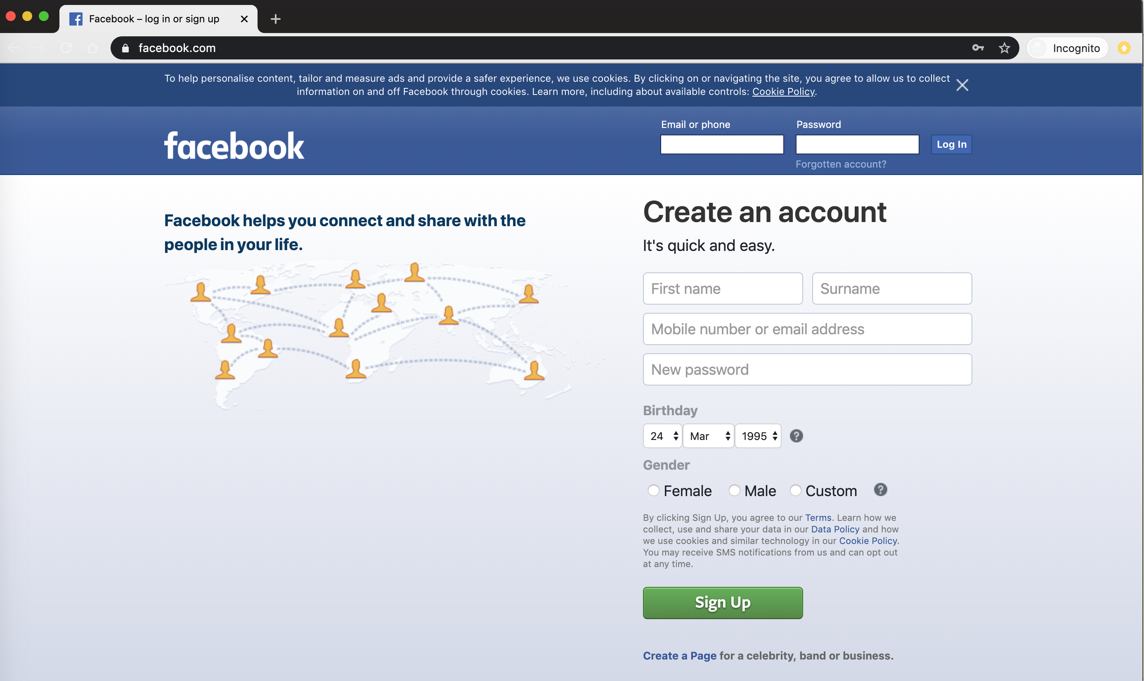

First, you will need to create an account. Fill in your name, mobile number or email address and create a unique password with at least 8 characters, one symbol (such as !?), one number and a capital letter.

You must enter your date of birth, as Facebook is not available to young children, so it will not let you create an account without confirming that you meet the age requirements.

Tick a box next to the ‘gender’ option which most describes you.

Once you have read and checked that all the information is correct, click the green ‘Sign up’ button.

If you signed up via email, you will receive an email from Facebook which asks you to verify your email address. See below:
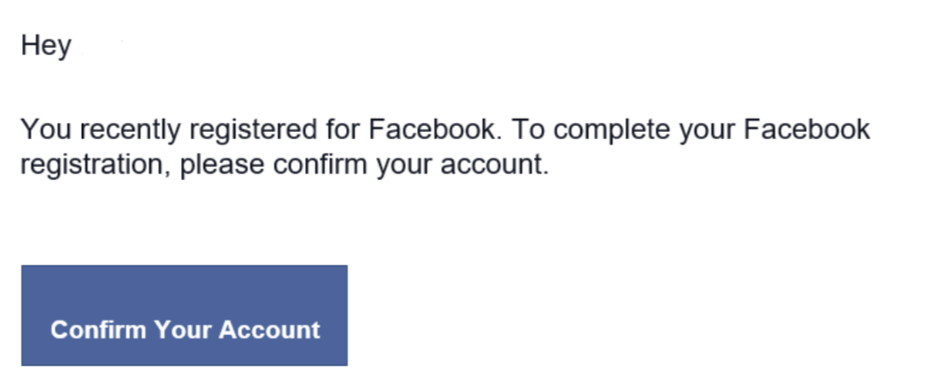

Click ‘confirm your account’.

You will then be directed to your new Facebook home page. Make sure to keep a note of the email or number that you used as this will be your username.

The password will be required for accessing your new account in future, so make a note of this somewhere safe too.

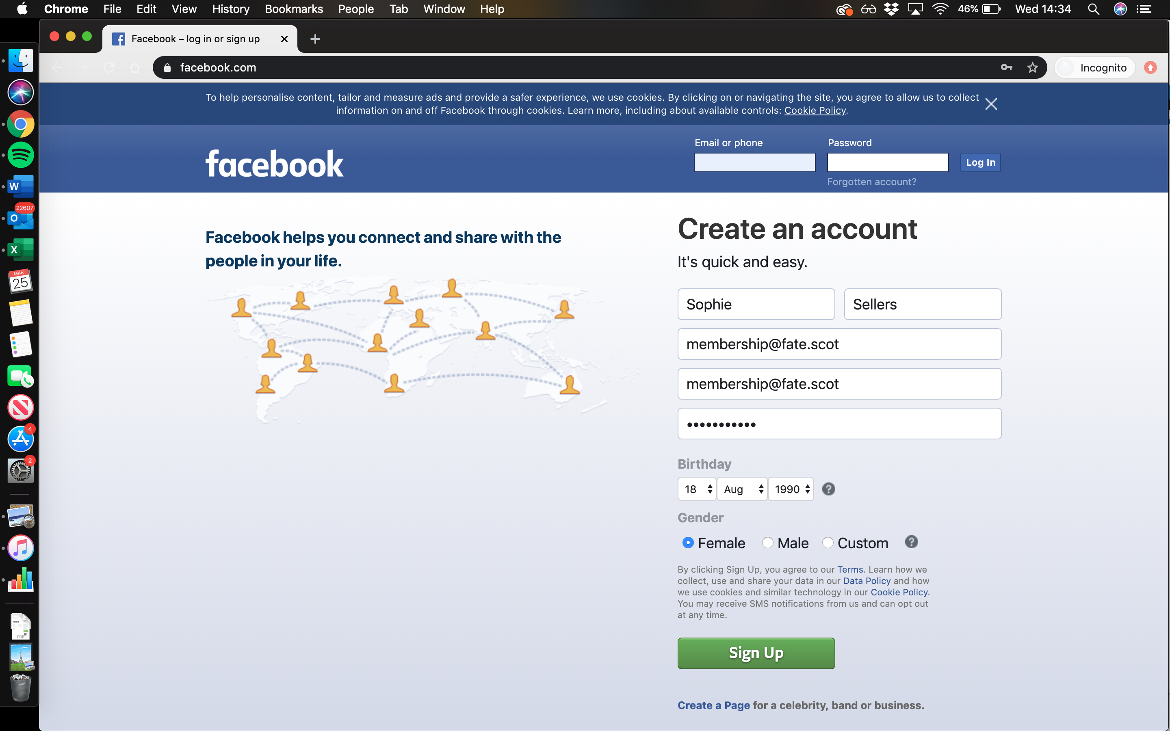

The page which you will see first is your activity feed. This is made up of comments, posts and articles which are related to friends, and interests that you indicate you are interested in.

To get this set up, first go to the tab which is shown at the top of the screen, it will say your name and have a circle next to it for a photo, as shown below.

Click here, and then you can start setting up your personal profile/information. This is information which tells people about you - you can share as little or as much information as you like. You can also add a photograph of yourself, which can make it easier for people to recognise you online.

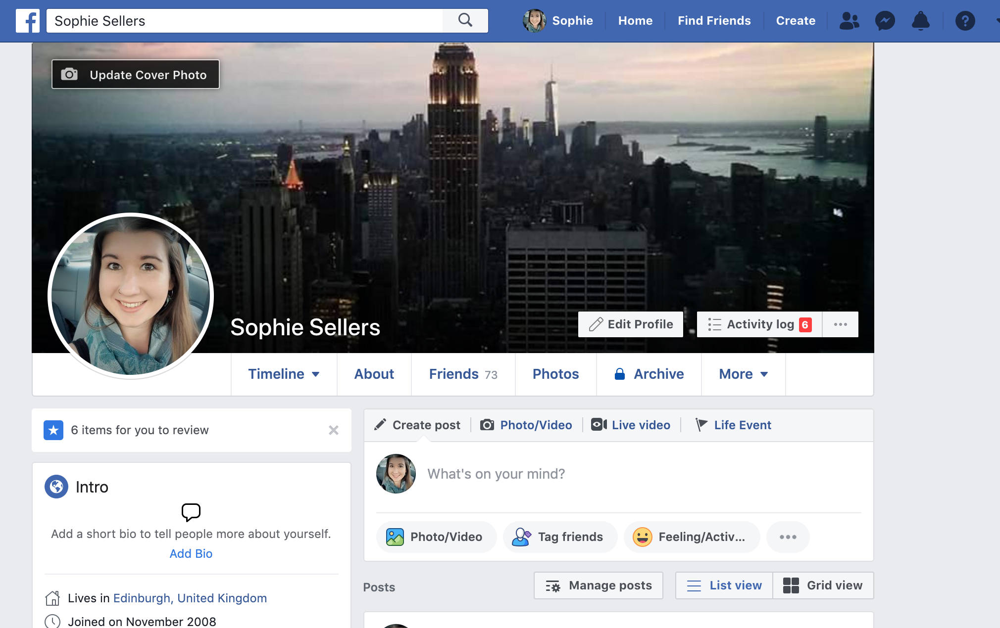

This is your profile page. To add photographs and information such as the town that you live, where you work/have worked and other information, you will firstly need to click ‘Edit Profile’ as shown above.
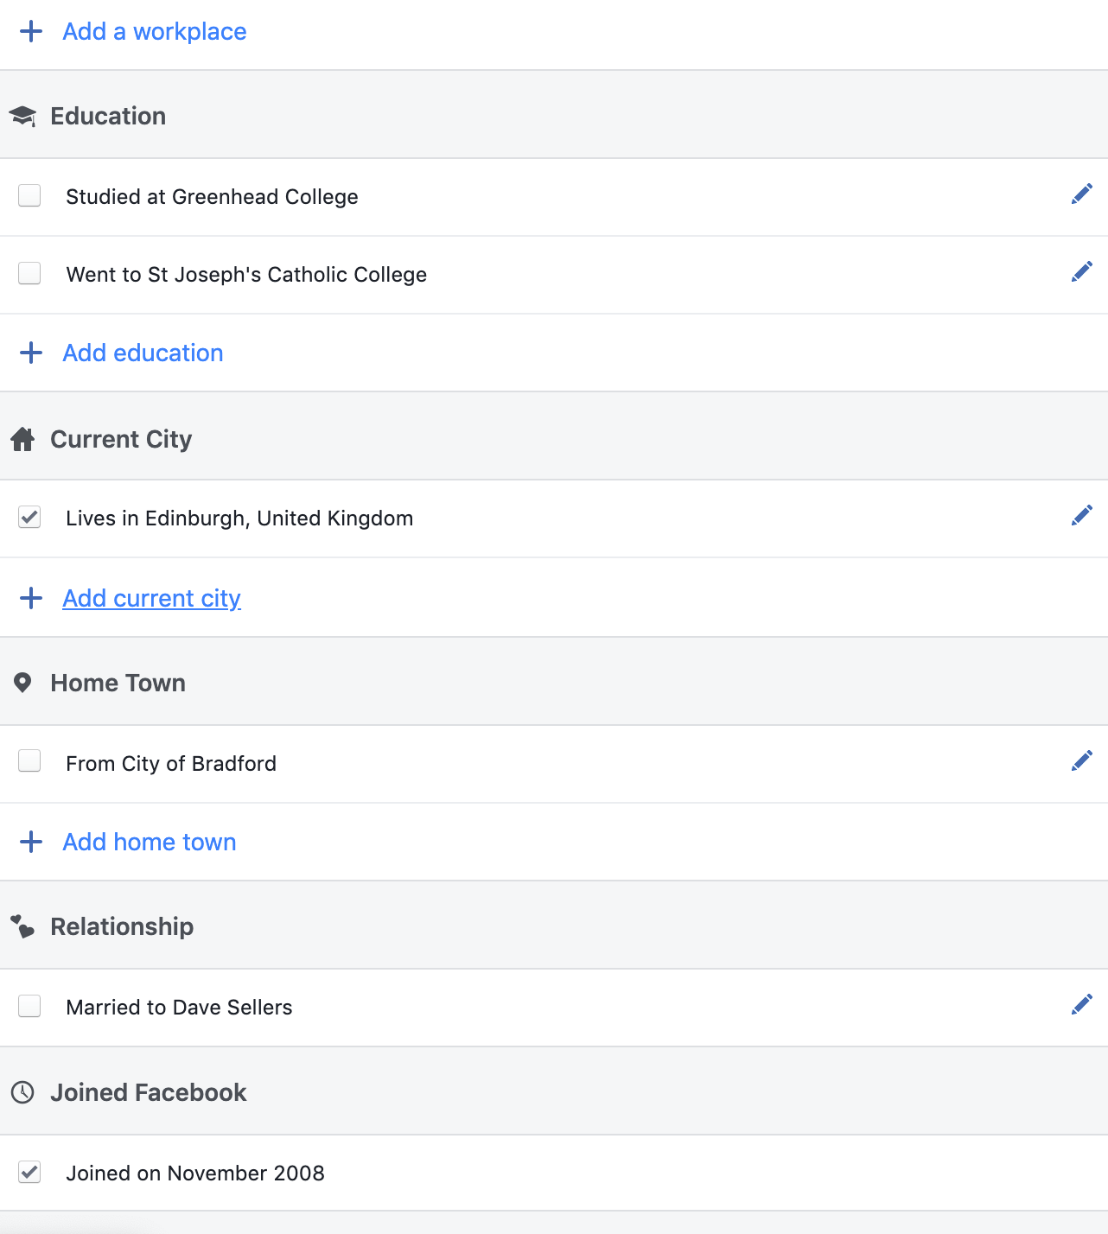

This is what you will see. Your version will be empty, and you can add as little or as much information as you like. If you are interested in finding old colleagues it can be useful to add your workplace, as people are able to search for colleagues by looking at who is linked to that place of work on Facebook.

To add a workplace, click the blue text ‘+ Workplace’.

You will see this:
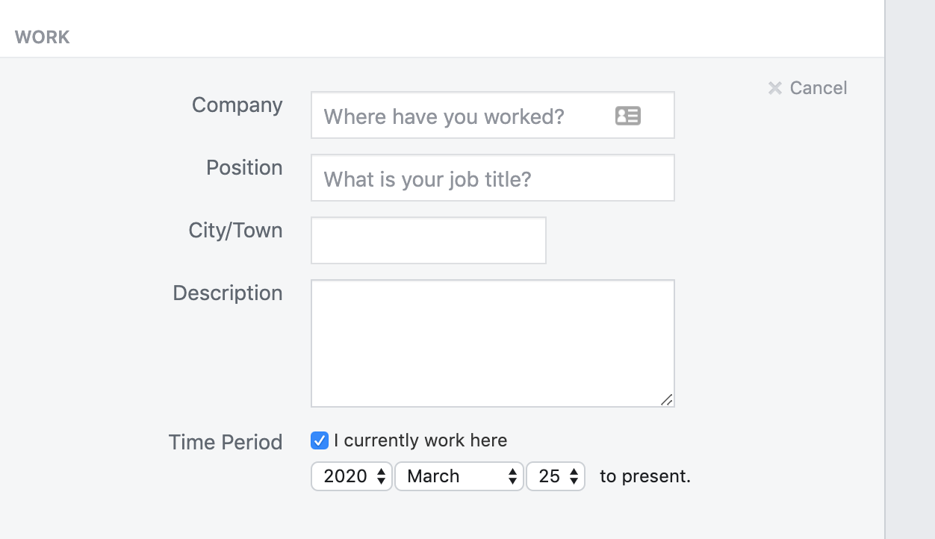

As you type your workplace, suggestions will appear like below:
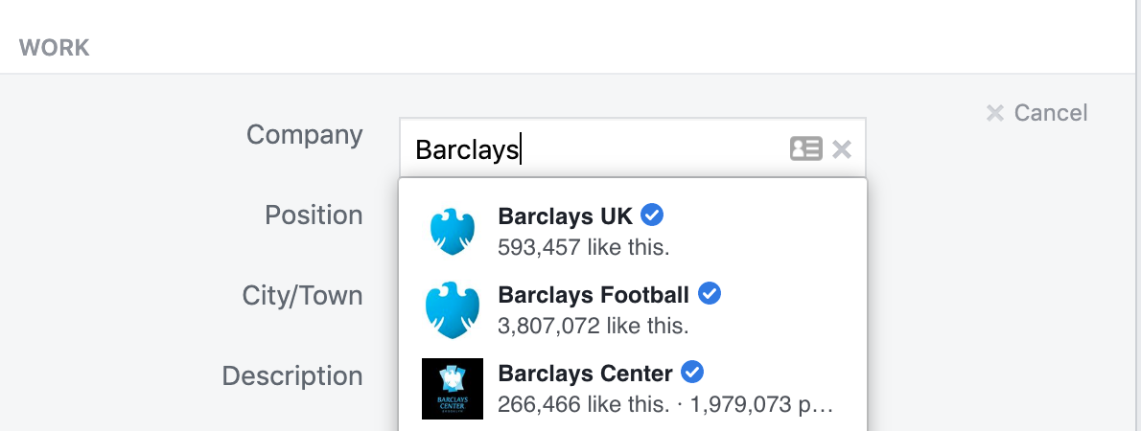

If you can see your workplace, click on it and the complete the rest of the information and click ‘Save Changes’.

This has now added your workplace to your profile, and you will be able to see it on your profile page on the left hand side.

Finding Friends and Family

Click ‘find friends’ which shows in the top search bar on Facebook.

You will then see this screen:
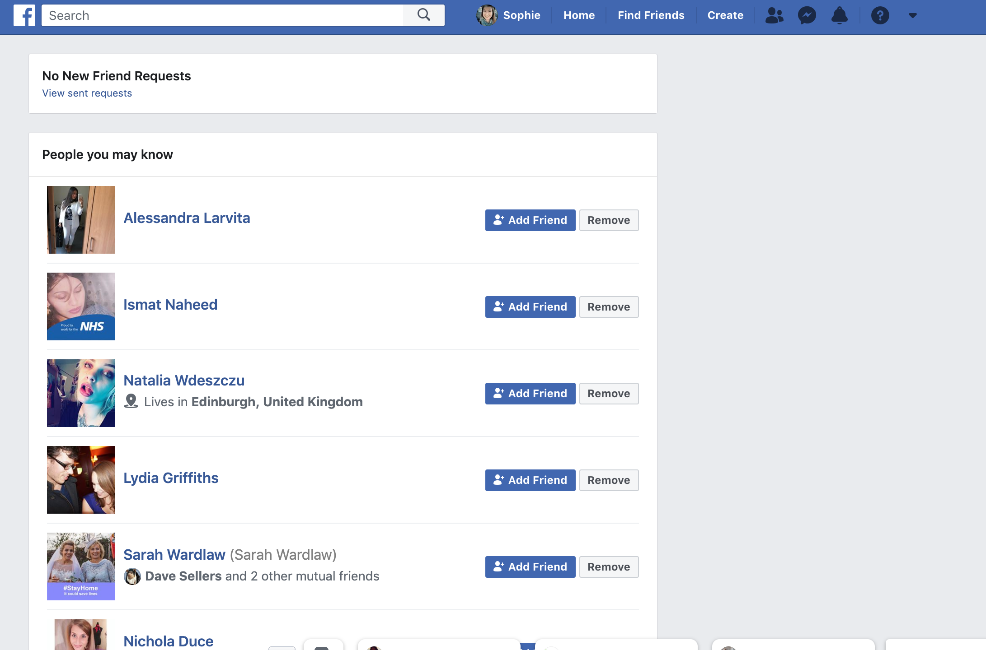

You will see a list of people who show up automatically. These are based on the information that you have added about where you live and work. They may be people local to you, people who have shared interests, or people who have added that they work in the same workplace as you. If you have added family members to your profile and linked to them in Facebook, then you will see people they know here too. If you know any of these people and would like to connect with them then click the blue ‘add friend’ button next to their name and picture. Adding somebody as a ‘friend’ enables you to see their profile, send messages to each other etc.

If somebody – a friend or family member has added you as a friend, then you will see their request at the top of this page. You can accept (check you know them first) or decline it.

It is wise not to accept friend requests from people that you do not know.

If you would like to find family or friends on Facebook there are a few ways to do this:

You can search for them by name in the top search bar, which is white and shows at the top of this screen. Type the name in, then hit the enter button which is an arrow on the right of the keyboard, pointing to the left.

Then click ‘people’ to view people with that name:

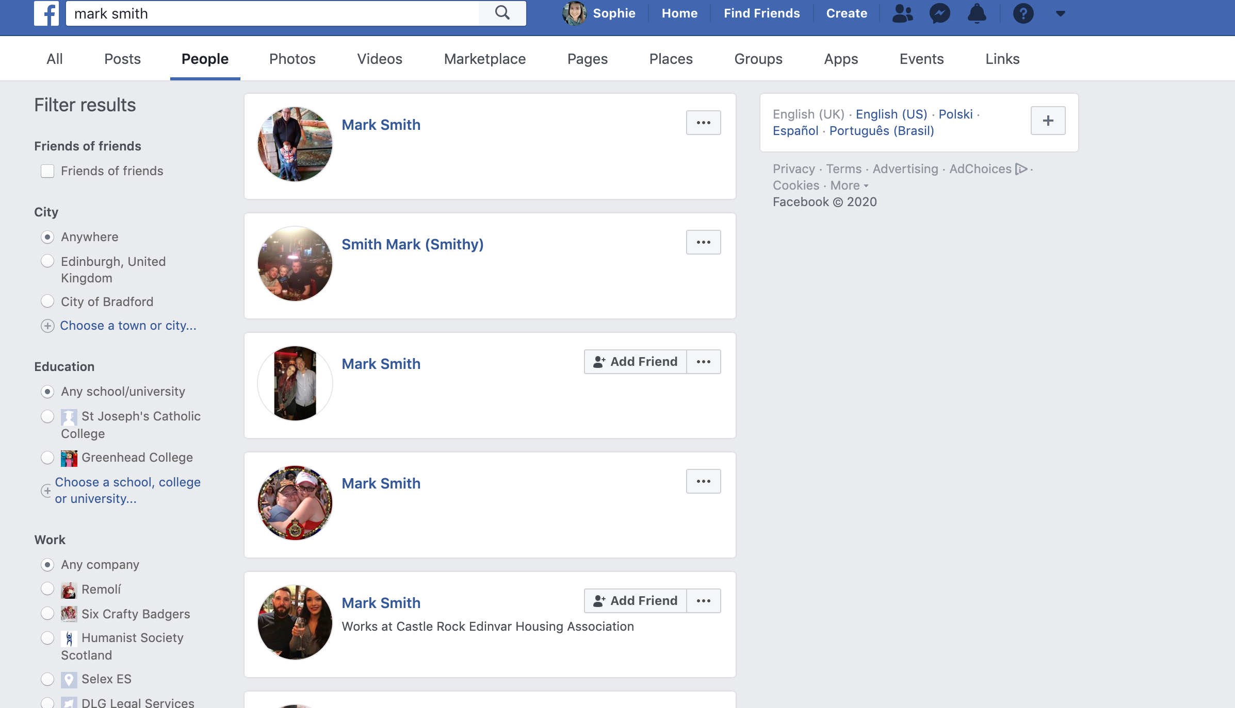

Some suggestions will pop up. If the name is common, then many options will show. If you can see the person that you would like to connect with, click ‘add friend’ which shows next to their name.

If you have added information like the school and workplace that you attended, you can click these and it will narrow down the list to others that have also added the same information, which makes it easier to find friends and family.

They will receive a request and will need to accept it before you can message them.

Once they have accepted, their picture and name will show on your friends list, you can find this here on your profile page, by clicking the ‘friends’ link like this:

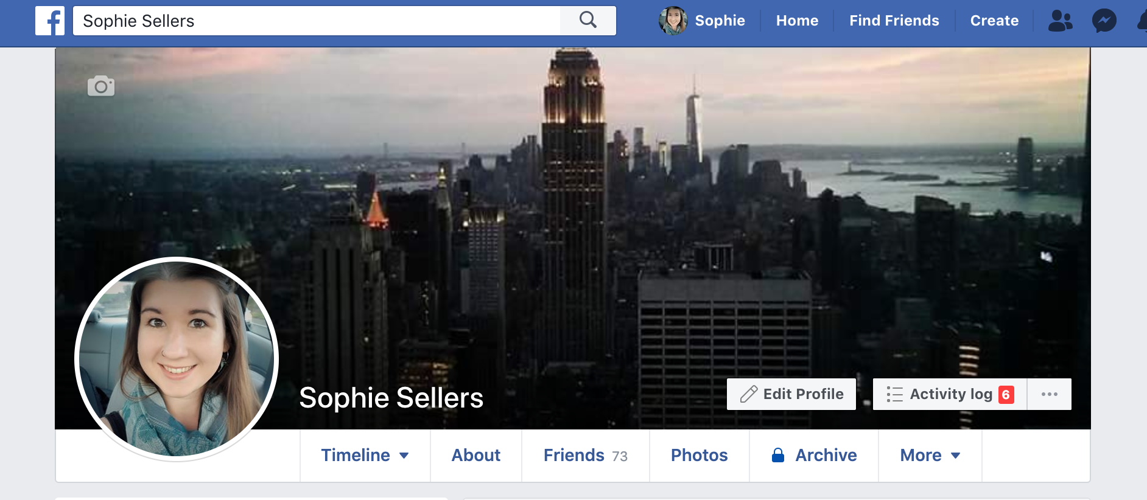

You will then see a list of family and friends who have accepted your friend request.

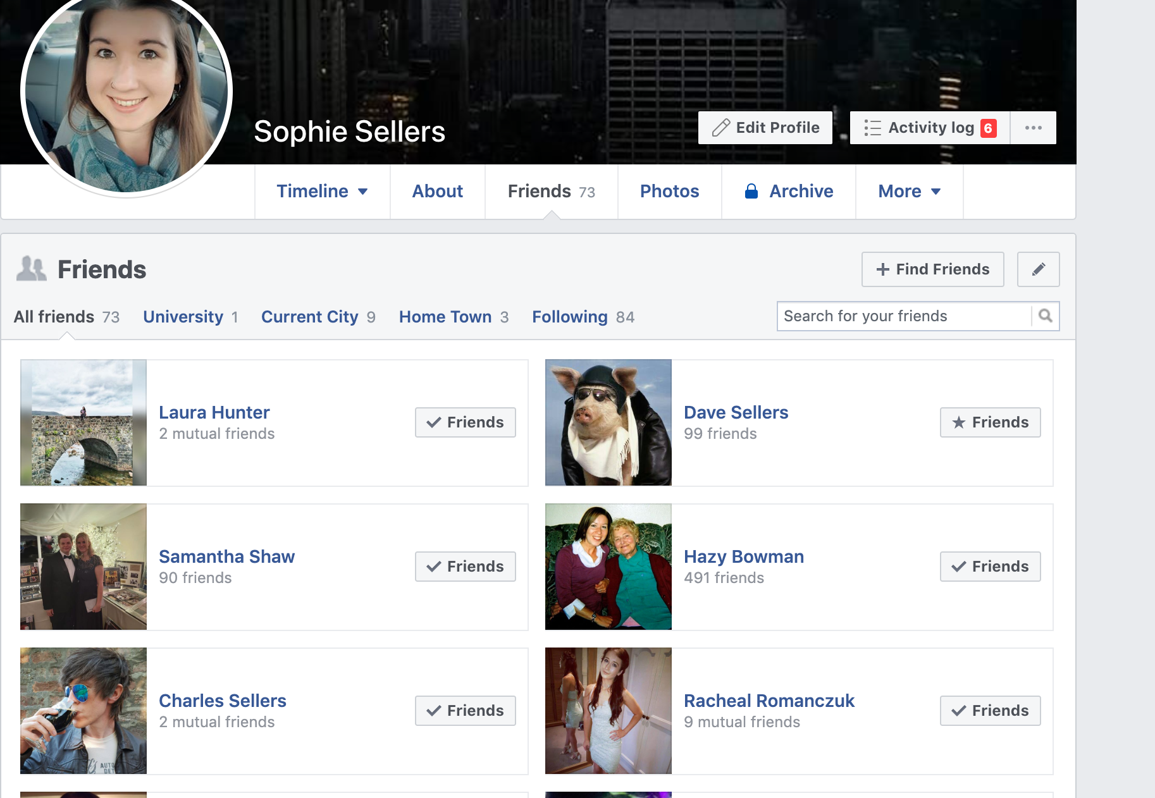

You can click on their names to view their profiles. You can see what they talk about and contact them through their profile.

To send somebody an online message, you can first click on their name to go to their profile.

You will see a screen like this:
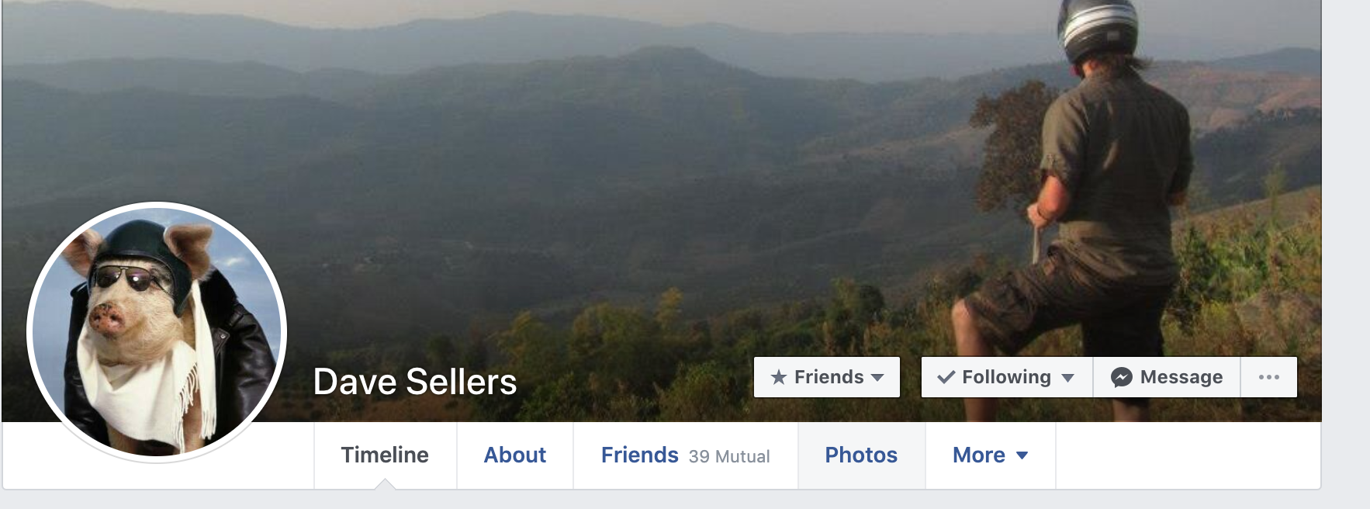

To send them a message, click the grey message button.

A small box will pop up. You can click on it and then type your message. You can click the ‘enter’ button or press the blue arrow and your message will send. They can reply to you and their message will appear in this box.

You can view all your messages with people (all the history is saved automatically) by clicking the message button at the top of the Facebook main navigation.

It looks like this:

A list will appear showing all your chats. To continue talking to somebody you can click it here or you can click ‘see all in messenger’ which is blue and at the very bottom of the list.

This will take you to a special page for all your messages. You will see the photos and names of your friends on the left and can click on them. Once you have clicked on the name of the person you want to talk to, type your message then hit the enter button or press the blue arrow message to send it. It will show in the big box above where you have typed.

To leave the special messenger view you can click on the white ‘F’ in the top left of the main navigation or click your name to go to your profile.

Creating a Facebook public post

If you would like to add a message to your profile – this can be how you are feeling, a nice poem, a phrase, news for friends and family then you can share it as a Facebook post. This post will be viewable by all your friends and family who are your Facebook friends so don’t share things as posts which are private or only intended for one person.

On your main profile page, or the Facebook home page, you will see a box at the top which says ‘create post’. You can click in this box and it will get bigger. You can then type your message, poem or comments. You can also attach photos if you already have them saved to your computer.

Once you are happy with your post, click ‘post’. This message will appear on your profile, and your friends and family can see it too.

