Shopping on Amazon

First, go to www.amazon.co.uk in your internet browser (Internet explorer, Chrome, Firefox).

You will see the Amazon homepage, it will look something like this:

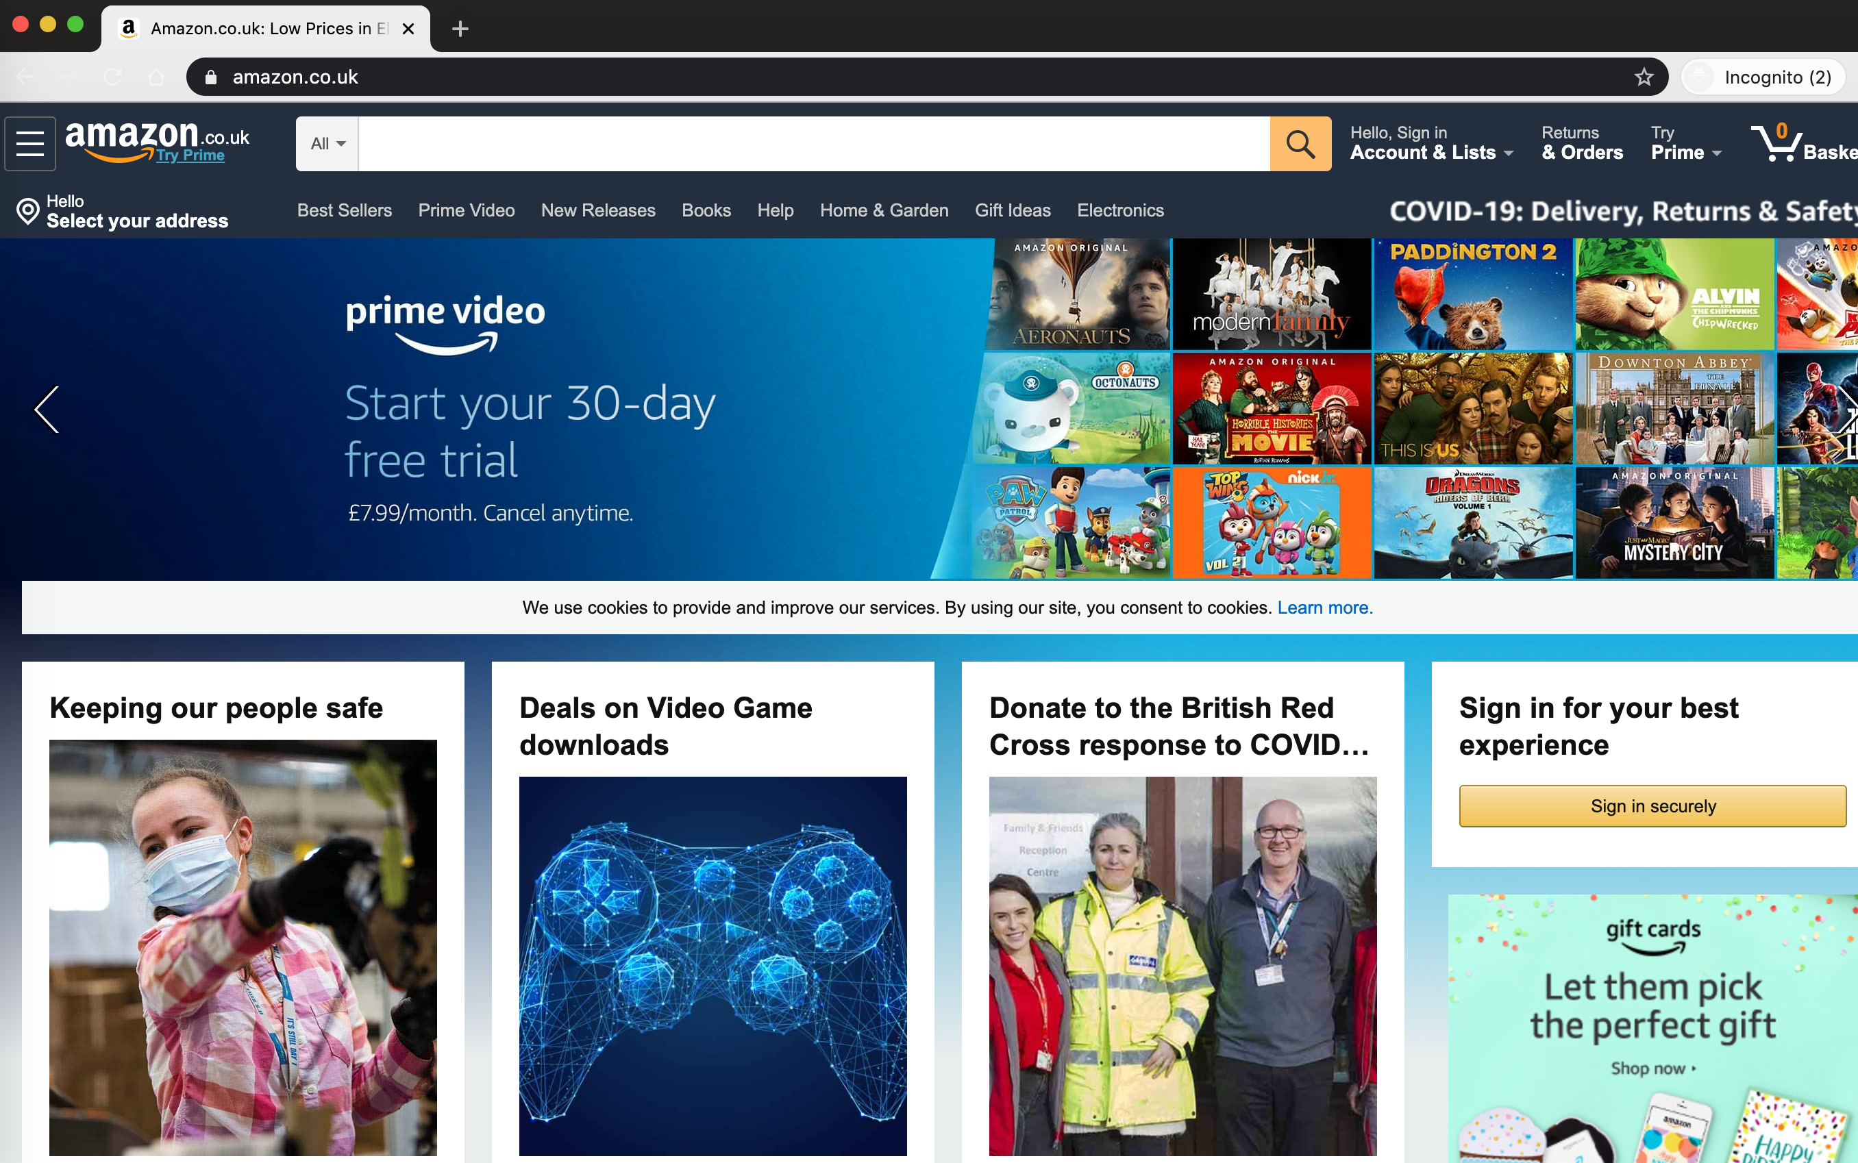

You can search Amazon for products using the search bar at the top of the page, shown with the arrow above.

I am using the Paddington Bear DVD as an example, but Amazon sell a very wide variety of products, from DVD’s, batteries, first aid supplies, cleaning products, pet food, DIY tools and even some fresh food!

Amazon may not be the most competitively priced for these items, but if you are struggling to get out or purchase things elsewhere, it can be very useful.

Once you start typing, you will see some suggestions appear, based on what you are typing. You can select these if they match what you are looking for or keep typing and then hit ‘enter’.

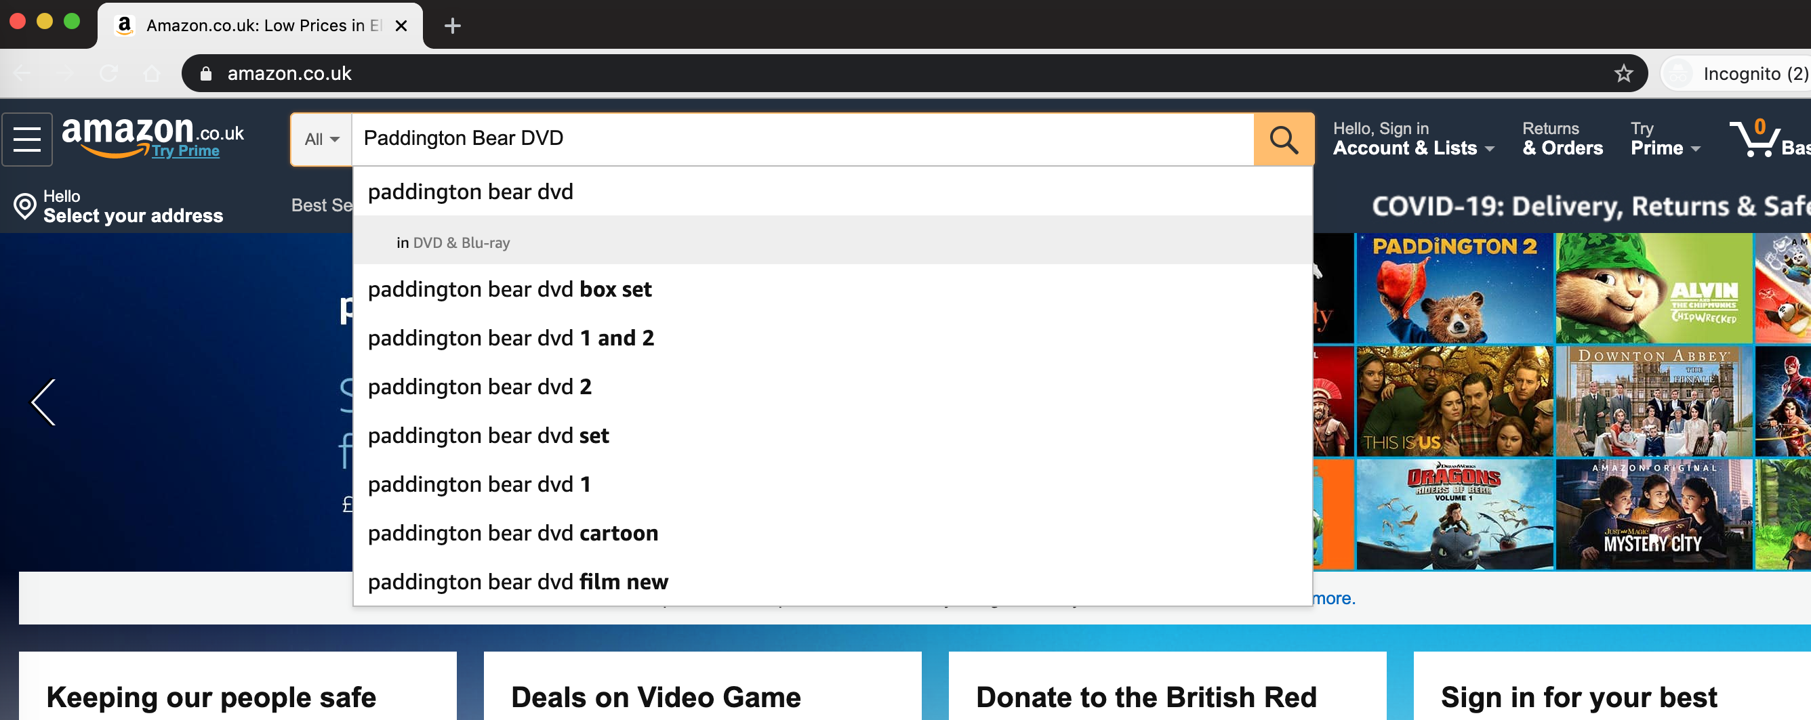

You will then see a screen showing your search results.

You will see a description of the item, a picture and a price.

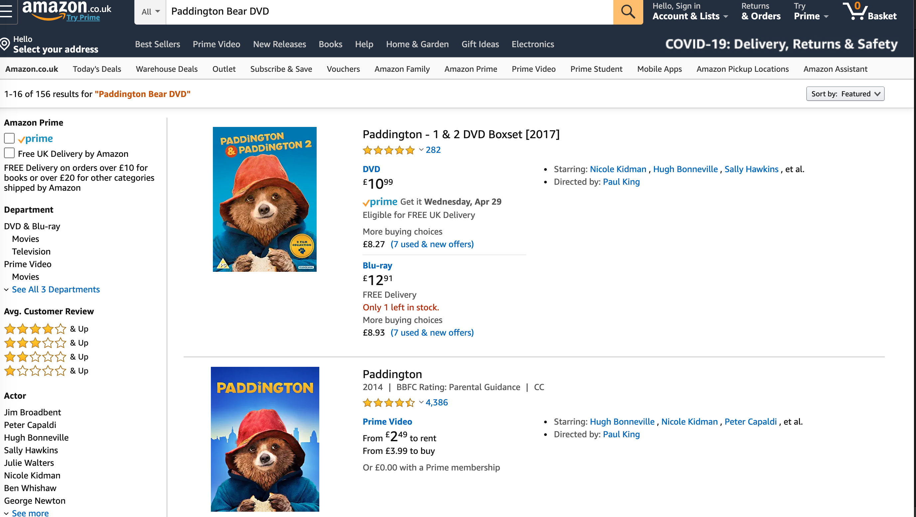

If you want to limit search results to those that include free shipping (£10 minimum spend on books, £20 minimum spend on other items) then you can click the box which applies this filter.

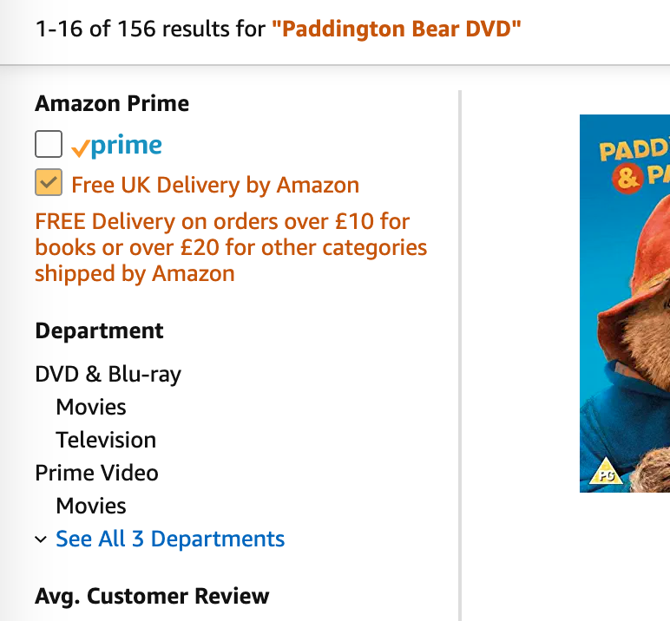

If you have found the item that you are looking for, you can see more by clicking on the title. This will show you a page which gives a more detailed description of the item and some reviews.

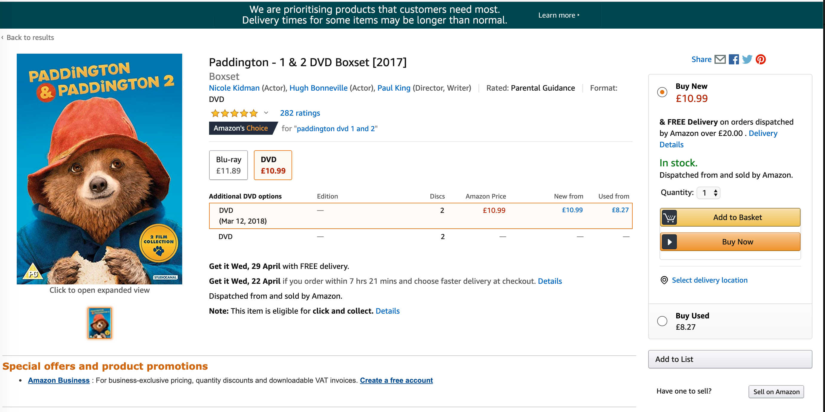

Here you will see the price, when it will be delivered and whether it is in stock.

If this item is not what you are looking for, or you want to look at some other options first, you can click ‘back to results’ as shown at the top left of the screen. This will take you back to the search results.

If you have found the item you would like to purchase, then click ‘add to basket’ if you would like to continue browsing Amazon for more items, or ‘buy now’ if this is all that you need.

I will continue with ‘add to basket’. If you want information on ‘buy now’ please scroll to this section further down in the tutorial.

Once you have added an item to your basket, you will see a confirmation like this:

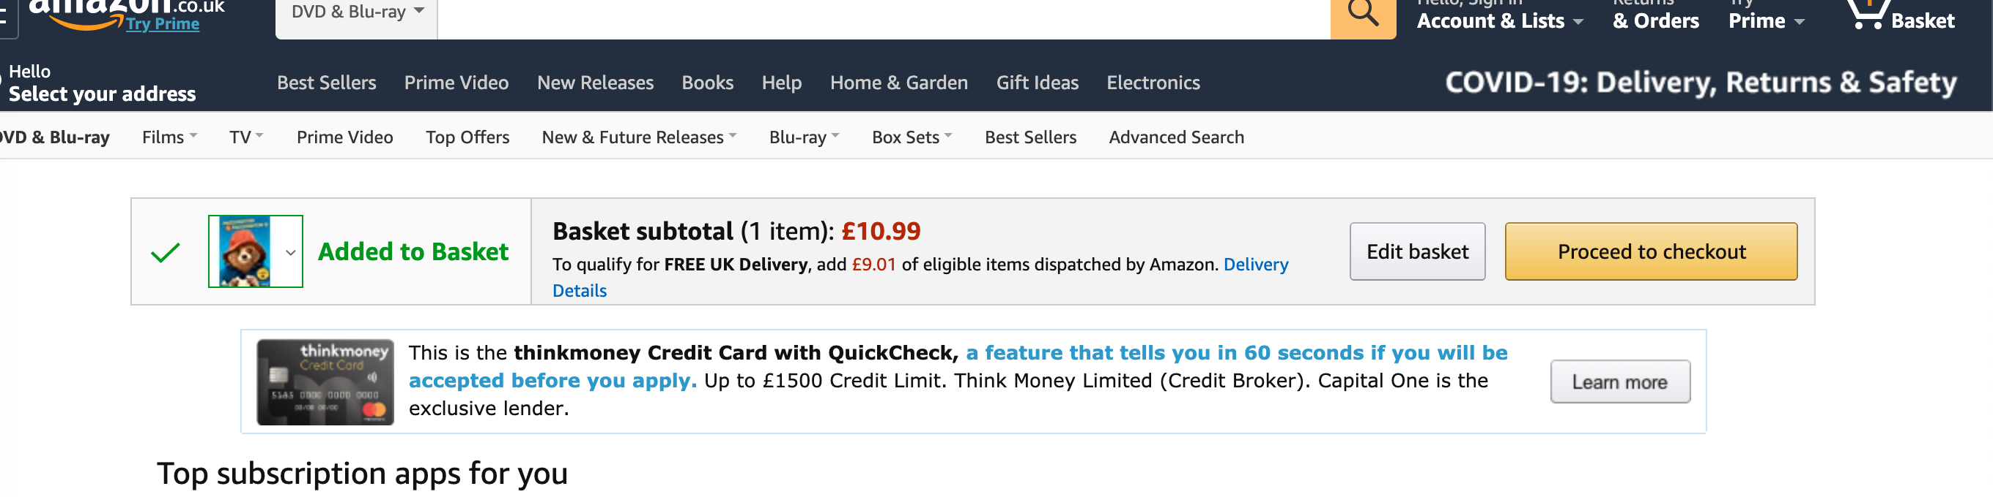

To continue searching Amazon for other items, click the Amazon logo in the top left-hand side of the screen.
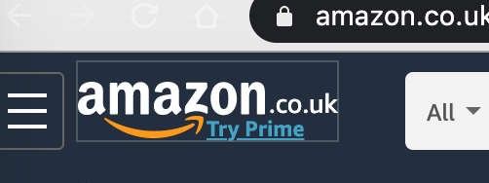

You will then return to the homepage and can search for other items.

Here I will use ‘coffee flask’ as an example. You will see that lots of different options are available. After clicking through and deciding which is most suitable, click into the item by clicking the title and click ‘add to basket’.

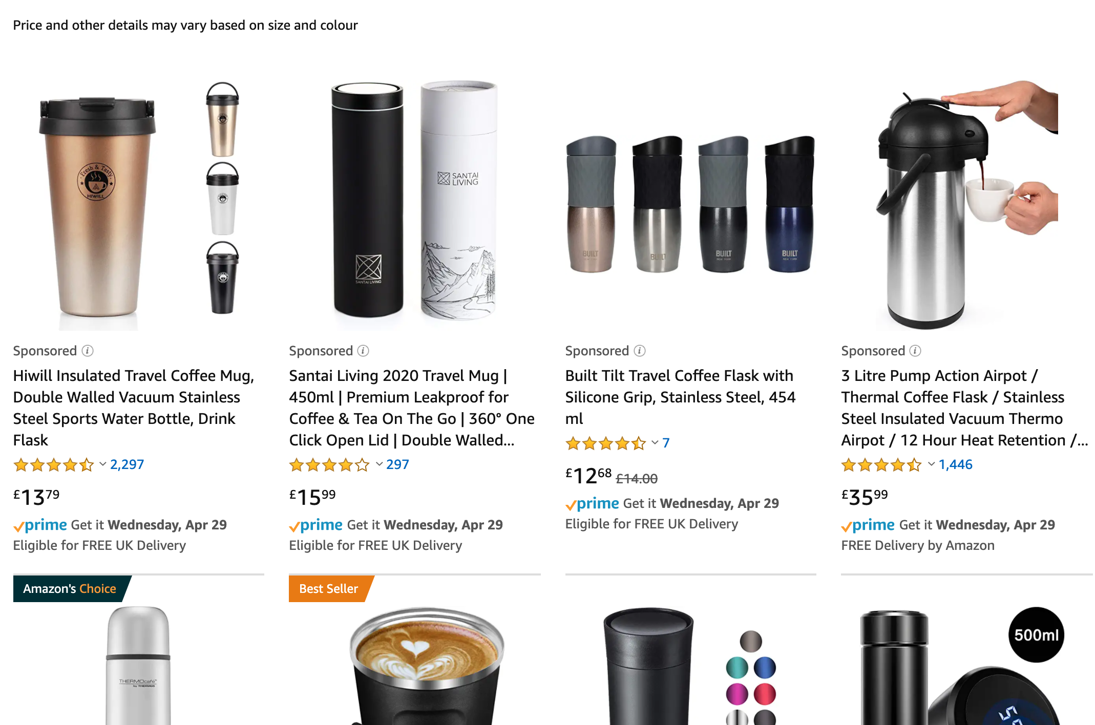

You will see a confirmation of your basket, and a summary which shows the total basket price so far.

This also confirms that I have gone over the £20 threshold to be eligible for free shipping.

If you have finished shopping, click ‘proceed to checkout’.
You will need to create an account to complete your order.

To do this, click ‘create your Amazon account’ which is shown in grey at the bottom of the screen and indicated with an arrow:

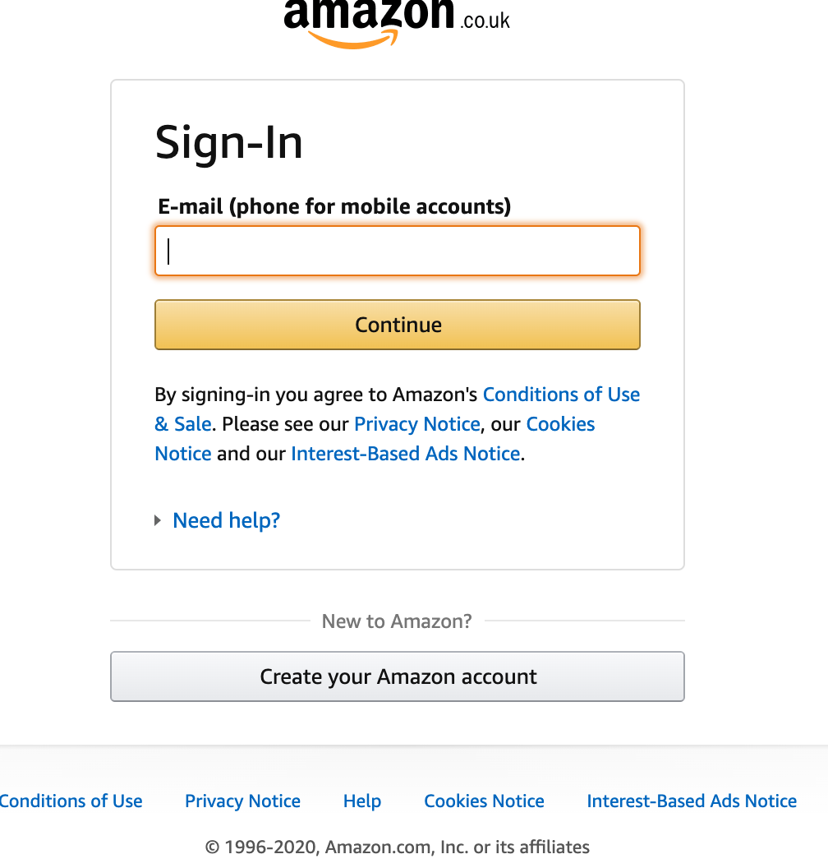

Then you will see this box, enter your personal information and complete each field.

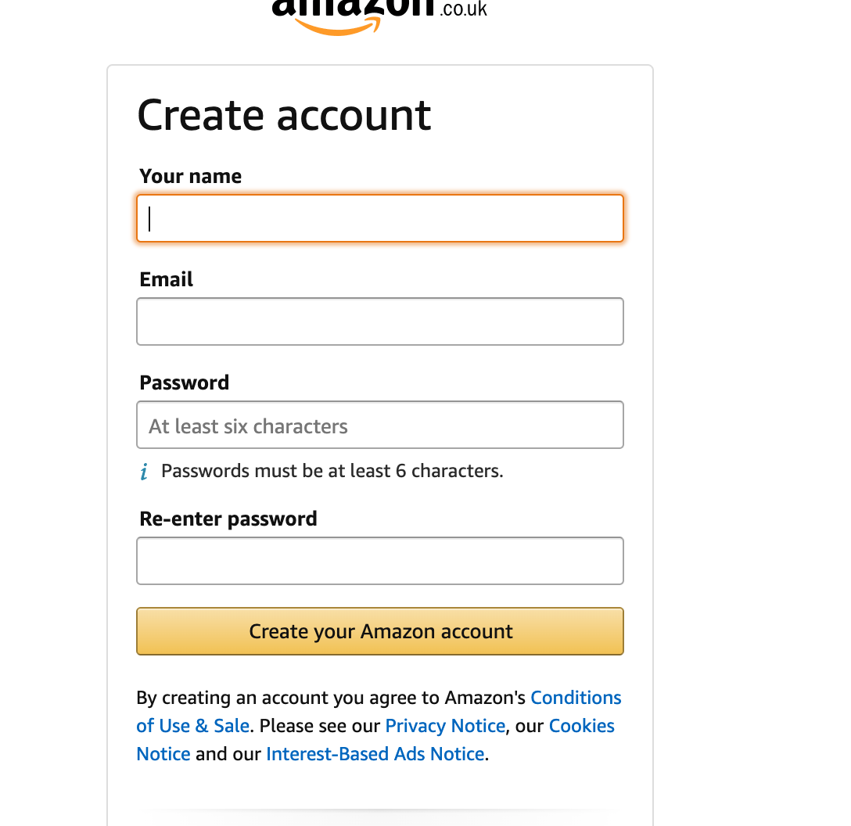

Make sure that your password is something secure and private, a minimum of 6 characters and that you keep a note of it/remember it.

Click ‘create your Amazon account’.

You will then be asked to complete your delivery and profile details, such as address and contact number. This will look like this:
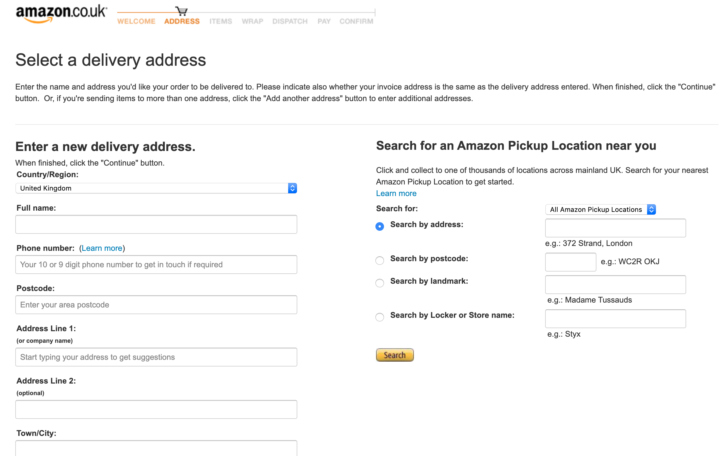

Add your personal information to each field.

If you would like your orders to be delivered to your home (recommended), then you
do not need to enter anything in the ‘Pickup’ section on the right-hand side of the screen.

On the screenshot below you will see the following:

A box where you can write instructions to the delivery driver i.e. instructions if your home is hard to find.

You can also click the blue text that says, ‘I can receive my package on Saturday and Sunday’ and untick the Saturday and Sunday boxes individually if you are not available then for parcels.

Additionally, under ‘Delivery location’, you can again click the blue text and enter a safe place instruction for the delivery driver so he can leave your parcel somewhere safe if you are out.

Once you have filled in your address and phone number, click ‘continue’ at the bottom of the page.
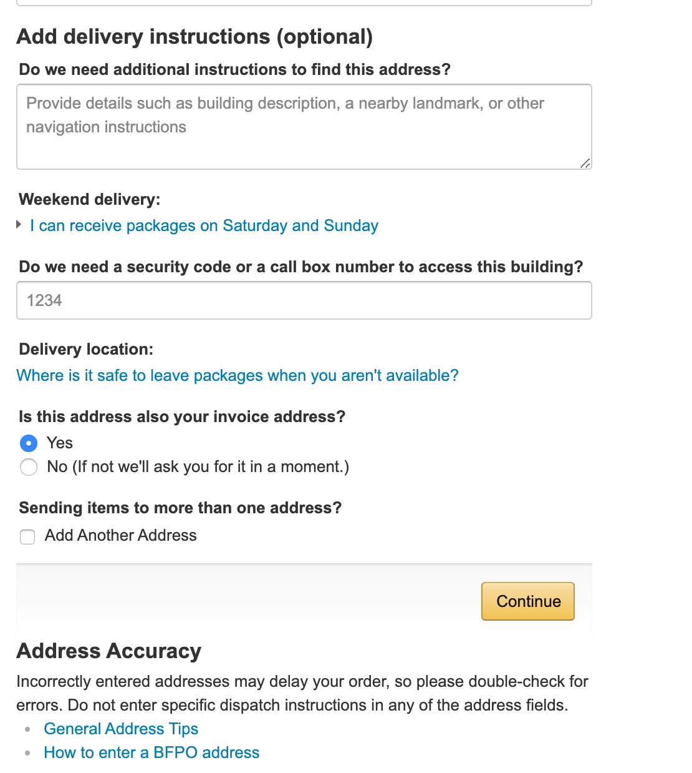

Next you will be shown shipping options, the premium delivery is automatically selected so make sure that you click the little button next to ‘free delivery’ and press enter. Ignore any messages about trials of Amazon prime*, as you would not need this unless you wanted to order from Amazon regularly.

*Amazon Prime is a monthly subscription which is roughly £7/month and gives you express next day delivery on some items, and free delivery on most items without having to reach the £20 minimum.

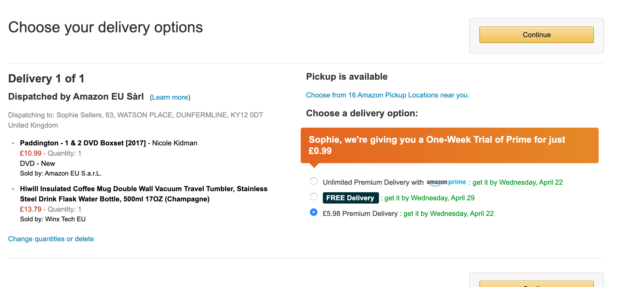

Next, you will need to add your card details, this will look something like this:

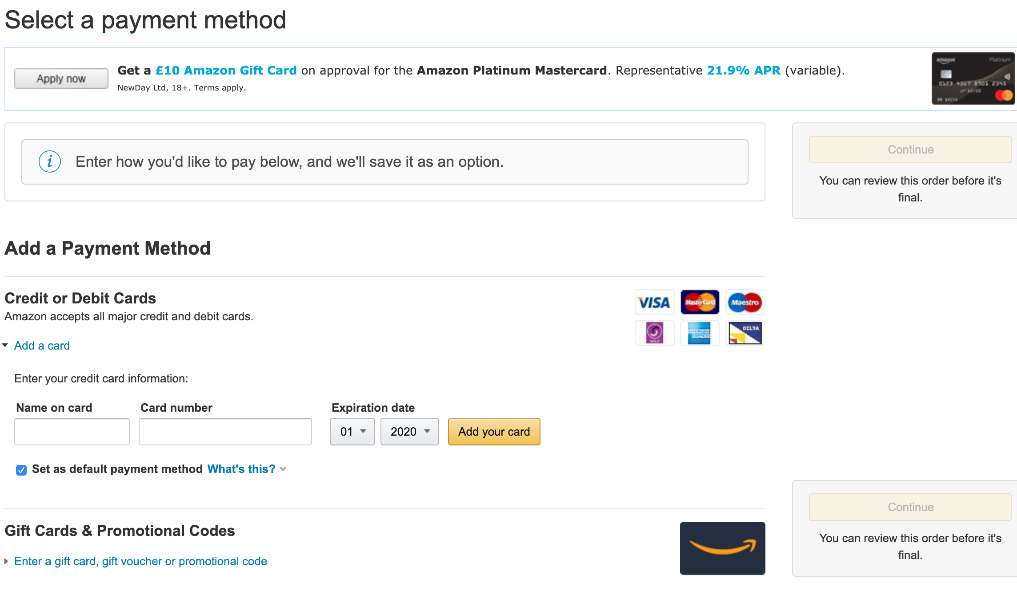

Enter the name as it appears on your card, and the long 16-digit number on the front without spaces.

Next, enter the expiration date clicking on the boxes to change the selected number.

When you are sure you have entered this correctly, click ‘add your card’.

Once your card has been added successfully, it will show like this:
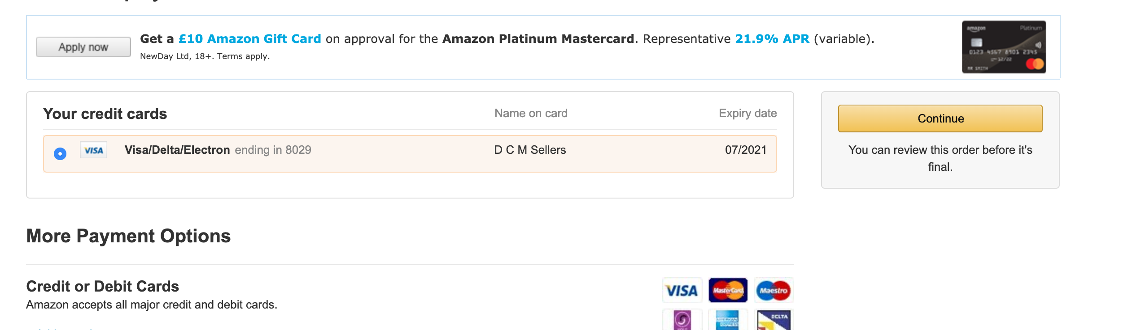

Click ‘continue’

Finally, you will see a summary of your order which shows:
- What you are purchasing
- Where it will be delivered
- The item price
- The shipping price (if applicable)
- When they will be delivered.

If you are happy with everything, and you are sure that your address is correct, click
‘buy now’.

The order will process for a few seconds, then you will be redirected to an order confirmation page and you will receive an email confirming your order.

Here is the order review page:
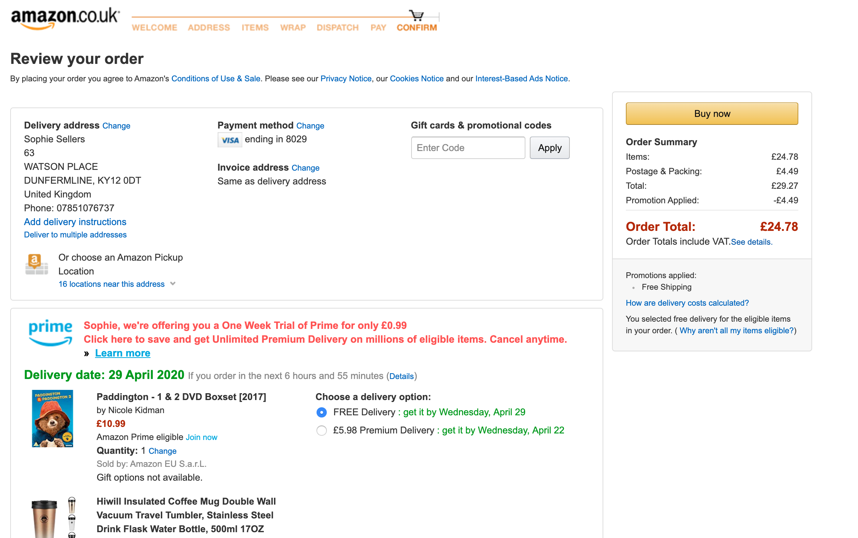

You can click ‘my account’ from the amazon homepage to see a summary of your orders, and this will give you any updates about despatch dates etc.

Here is where you can find your order summary:

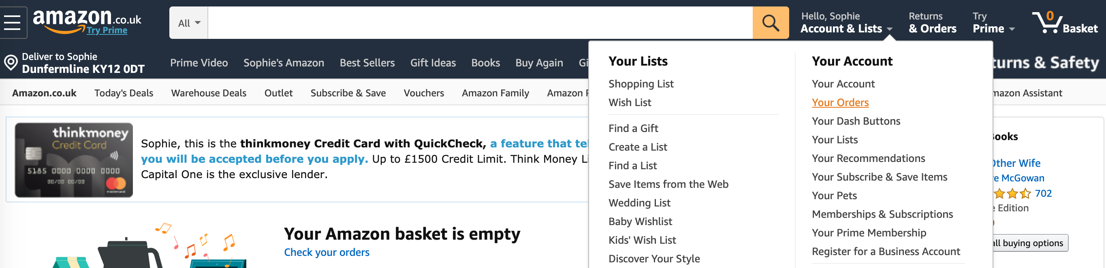

If you need to use Amazon again in future, you will first need to click ‘login’ if you are signed out. You will need to enter your email and password that you created earlier, then you can start shopping. Your delivery address and card will be automatically saved meaning you can check out quickly.

